**Build Doc**

1. To build the project you need to run the Maven pom.xml
2. Run Maven clean

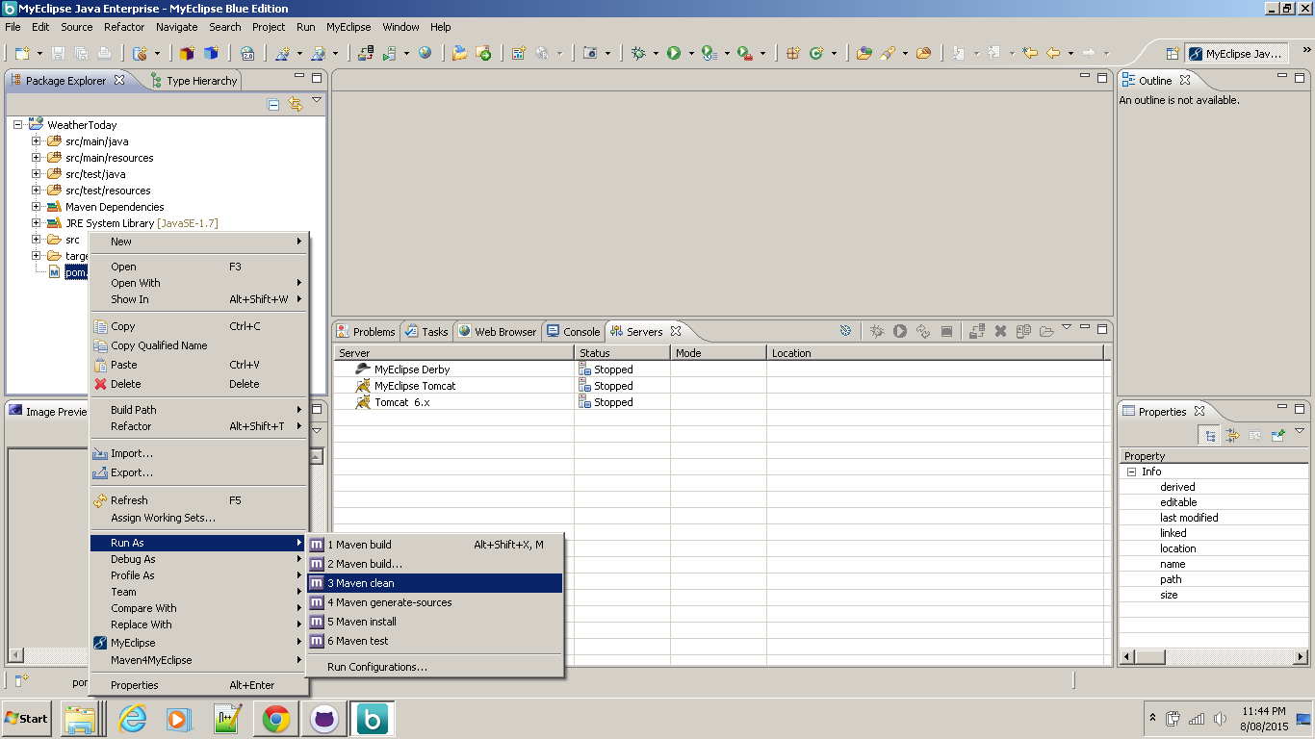

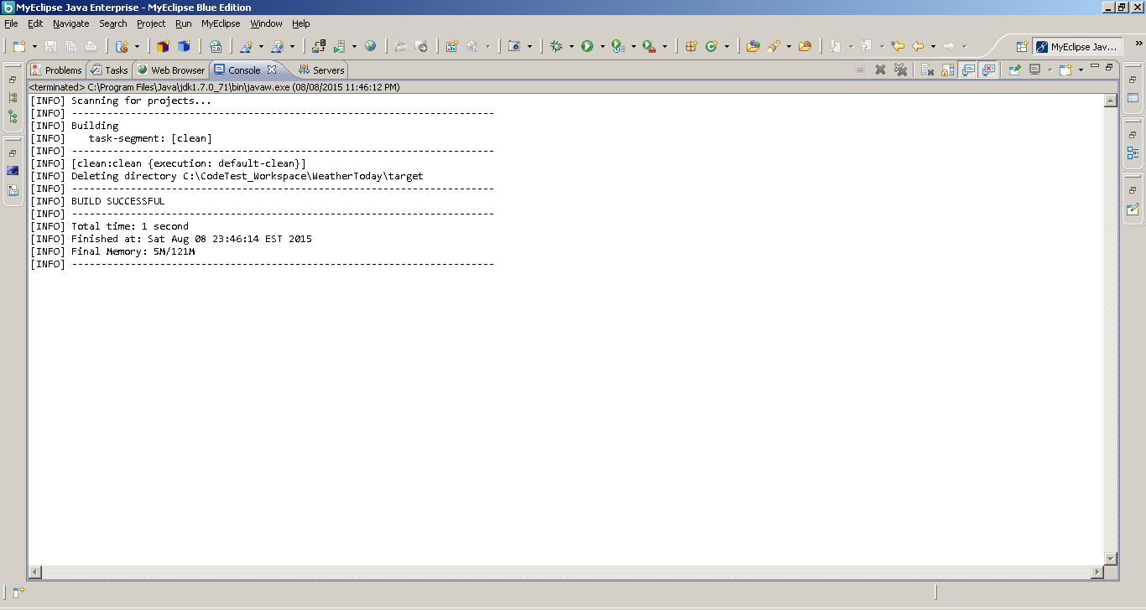

1. Run Maven Install

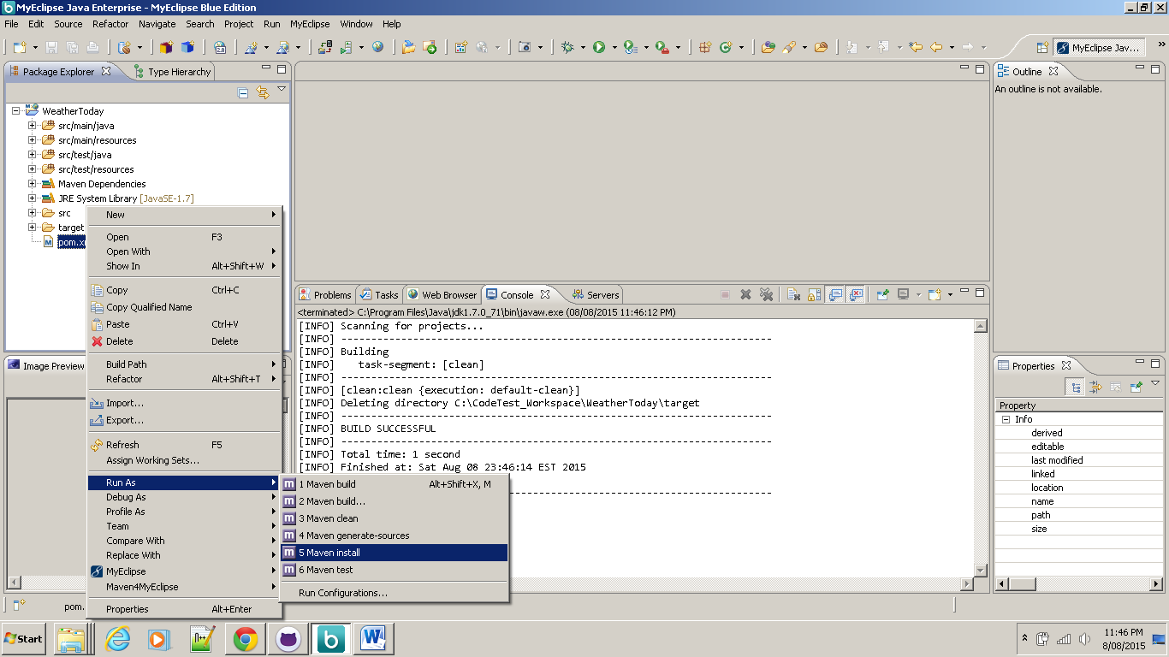

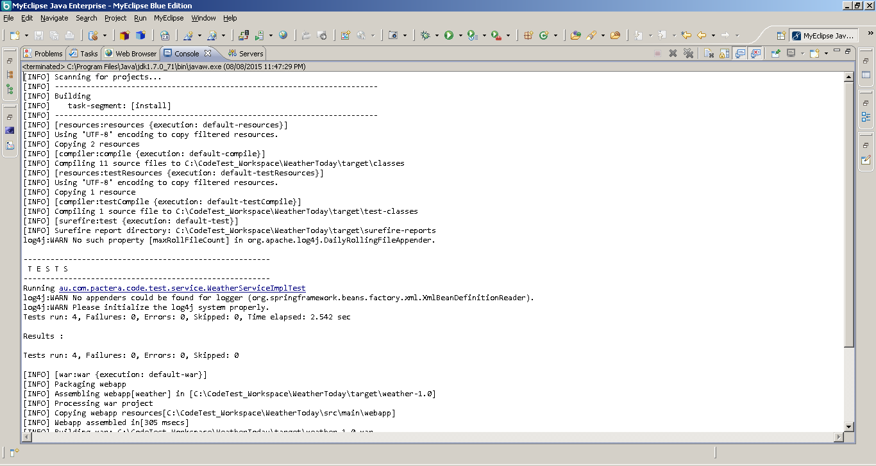

1. After the **weather.war** file is generated deploy it to any web/app server
2. Make sure the **context** **root** of the application is set to ‘**/weather**’
3. For Tomcat, copy weather.war file to webapps directory
4. Ensure the version of Tomcat supports JDK 1.7
5. Start the server
6. Once started, access the application at <http://localhost:8080/weather/>

Application screen shot

